Sunday 18th April 2021
Our Cross-Country is open for the Day!
Coates Farm, Stanton Long, Much Wenlock, Shropshire, TF13 6LQ
(on Google and Ordnance Survey maps & will be signed from the B4368 main road)
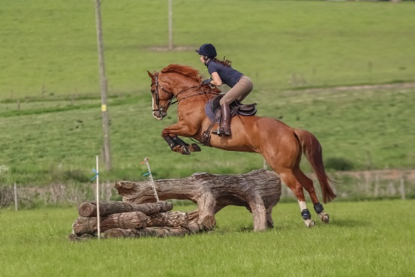
A XC training ride of approx 3 miles – includes corner, coffin, into-space, quarry as well as many natural fences.
Course A: Jumps between 60cm and 80cm high
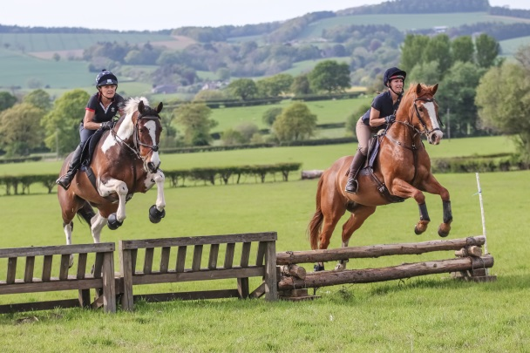
Course B: Jumps between 80cm and 100cm high
The two courses run side-by-side.

All jumps built to be inviting/confidence building – ideal for young horses. Course opens at 12 noon.

‘Inter-hunt’ style Relay Race
An ‘Inter Hunt’ Relay is a knock-out competition where two teams of four horses and riders jump over two identical courses against the clock, collecting time penalties for any obstacles knocked down along the way. The fastest team after penalties then go forward to the next round!

Jump height will be approx. 80-100cms with possibly some higher alternatives. First heat at 2.00pm.

Open to all ages and to any group of 4 friends looking for some fun! Rosettes to the first 4 teams and bottles of champagne all round to the winning team!

Entries fees:-
Cross country: £18.50 per horse for emailed entries by noon on Friday 16th April (to avoid handling cash) and £25.00 therafter or on the day.
Relay race: £45.00 per team of 4; emailed enties by noon on Friday 16th April only.

Take-away refreshments available.

Schedule request & enquiries contact: 07551 360289 (line only open 14th-18th April), or email (at any time) to duncanjshill@gmail.com

Raising money for the Midlands Air Ambulance

ENTRY FORM
Coates Farm Cross Country & Relay on 18/4/2021

Scan or take a photograph and email to duncanjshill@gmail.com

Cross Country Training Ride

Riders’ names Early entry fee at £18.50 each

TOTAL ___________

‘Inter-hunt’ Relay Race

Team Name Rider’s Name Horse’s Name
ENTRY FEE £45.00

TOTAL PAYABLE ___________

Please send payment to: D J Hill
40-47-58
00207918
With the lead rider’s name as a reference

Lead rider’s contact details (for track-&-trace & cancellation)
Name:
Email address:
Mobile tel nr:
TEAM RELAY RULES

- Teams run in a ‘drawn order’, with two teams of 4 riders at a time over a ‘mirror imaged’ course of obstacles against the clock with 5 time penalties for each fence down. First riders start the clock as they cross the line, complete the course and hand a baton (whip) in a designated area to the next rider until all four have competed and rider number four stops the clock as they cross the line.
- Refusals cost the team time but do not incur penalties.
- The winning team goes forward to the next round and the process is repeated until the final two remaining teams battle it out to determine a winner.
- Course to be combinationn of knock down and permanent fences; horses must pass between any flags.
- If a team member fails to complete the course due to retirement or fall, then the next team member must complete the round from the point of retirement/fall and then continue to jump their own round. A 10 second penalty will be added per incident. A team member may not complete a previous member’s round until that member has retired or fallen.
- The draw will take place at the secretary’s trailer at 1pm on the day of the event where it will then be displayed.
- The judge’s decision is final.

IMPORTANT – PLEASE READ

CONDITIONS OF ENTRY & CORONAVIRUS INFORMATION

All dogs on leads at ALL times (even by the vehicles)

This event will be run in accordance with Government coronavirus guidelines.

- If at all possible and to avoid the use of cash, bookings and payments should be made via email and in advance using the attached form and by 12 noon on Friday 16th April.

- Start times.
Cross country: there are no set start times. The course opens at 12noon. Please give your name to the starter who will check you off the list of entries.
Relay race: the first round of heats will commence at 2pm. A draw will be dispayed at the secretary’s trailer.

- There will be no toilets. Sorry!

- All relay team riders MUST wear gloves (for safely passing the whip!). Body protectors and crash helmets must be worn on the cross-country.

- Riders travelling together must be from the same household.

- Riders can only ride in groups of up to 6 people but must maintain a 2m distance at all times.

- Everyone must maintain a 2m physical distance at all times whilst on site.

- Anyone showing any signs of Covid-19 symptoms should be self-isolating and must not attend the event.

By attending the Coates Farm Cross Country Day and Relay, the attendees acknowledge and agree that although Coates Farm, the South Shropshire Hunt & Wheatland Hunt have taken every precaution and followed Government Guidance, it is impossible to eliminate all risk and there remains the potential for unintended transmission of COVID-19.
All those attending must play their part in minimising the risk to themselves and others by complying with the Government Guidelines as well as any on-site instructions and signage. The Organizers have the right to refuse entry or request departure from the site should there be any breach of the Covid-19 protocols put in place.

No claim can be entertained for anything that may happen to riders, onlookers, their property or animals in connection with or arising out of this ride. It shall be deemed a condition of entry that each entrant shall agree to indemnify the organisation against any legal action arising out of any accident, damage or loss. All riders must be covered by their own Public Liability Insurance.

A phographer will be on site. Photographs will be available afterwards at https://somethingfromthehart.com .

Any queries can be emailed to: duncanjshill@gmail.com

Organised by the South Shropshire & Wheatland Hunts

